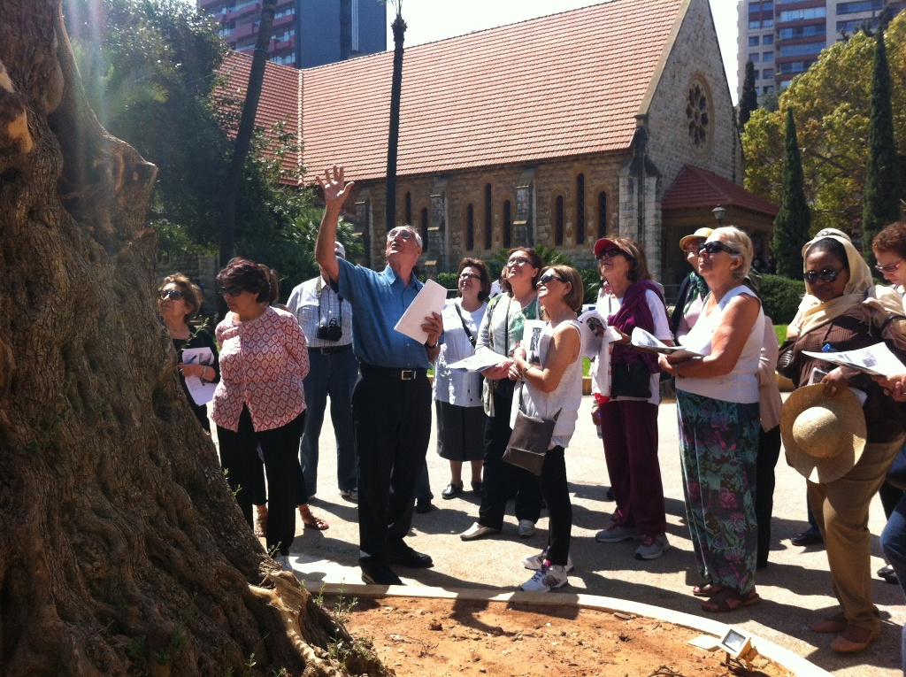
Docent Training Program 2018
Become a Docent for AUB’s Ancillary Botanical Garden
AUBotanic

Prepared by Dr. Salma Talhouk & Ranim Abi Ali

Manual

Become a Docent for AUB’s Ancillary Botanical Garden
Contents:
- What does a docent do?
- How do you become a docent?
- What is expected of docents?
- AUB botanical volunteer opportunities
- What are the benefits of being a docent?
- Docent Training Program Courses
- Docent Training Schedule
- Letter to Prospective Docents
- Docent Application Form

What does a docent do?
Botanical Docent is a title for volunteers who are given the needed training to serve as a Botanical guide and educator on plants in the university campus. Depending on the training involved, they may also become a volunteer to AUB’s greenhouse nursery or to AUBotanic’s planned events and exhibitions, where they may also serve as an informant, guide, or facilitator. If you are interested in the docent training program please indicate this on your completed application.

How do you become a docent?
Docents undergo a professional training program involving specific information they require to be a Botanical guide, to be prepared for any questions from visitors, and be well equipped to help with planned Botanical related events organized by the university.

What is expected of docents?
To receive a docent certificate, volunteers are required to take the Docent Training Program Courses and fulfill 25 hours of docent service in a semester (fall or spring). They become involved in events concerning the AUB campus ancillary botanical garden, and commit to the Special Events and Exhibits after completion of the courses and receiving their docent certificate. Upon receiving the docent certificate, docents are expected to commit for a minimum number of hours per week to support and lead various ongoing programs seen in the section below to serving at least one year of volunteer service in this area.

AUB Botanical Volunteer Opportunities:
Community Docent Volunteer: Includes working as a greeter, ticket collector, path guide, and other event-related duties. Also assists in planning, preparing for, and hosting special functions and special events. This includes events such as tours for elementary and middle-school classes, and lead on-site field trips for school groups and participation in community school gardening projects with youth groups. Docents educate students on topics such as pollination, plant adaptations, how seeds grow and the many uses of Mediterranean plants. Some special events may involve committee assignments. Volunteers who work only in Special Events are asked to work a minimum of 18 hours per year to maintain their status as active Garden volunteers.
Time Commitment: Varies with events; shifts may be anywhere from 2-4 hours.
Training requirements: Docent Training Program
AUB Botanical Exhibits Volunteer: For one-time, short-term or time-limited volunteers. This is an “as needed” position for Gardens volunteers and docents only. Volunteers may help to install or disassemble AUB Botanical related exhibits and assist during receptions when needed.
Time Commitment: Varies with exhibits and events
Training Requirements: On-the job training.
Maintenance Volunteer: Activities including gardening, planting, pruning, weeding…etc.
Time Commitment: Minimum of two hours per week
Training Requirements: On-the-job training (Training Program not necessary but encouraged)

Please note that the availability of positions in these areas varies widely, as do the requirements for each position.

What are the Benefits of being a docent?
The docent program provides opportunities for the members in service to be actively involved in preserving and managing the campus, experience working in AUB, and be involved with its community. Above all, the program gives valuable knowledge and appreciation of history, nature, and culture. Whether the enrollers are current students of AUB or whether they are just part of the general community looking for specialized experience and training, the program gives equal opportunities for anyone willing to apply. Being a docent also provides a good background for other plant related fields of work and a good basis on establishing new contacts or meeting people sharing the same interests.

Docent Training Program Courses
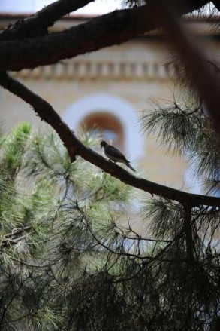
The following are the required courses to complete the docent training program and receive the docent AUB certificate of completion. This program consists of 10 courses (22 hours) and is scheduled to be announced based on the numbers and availability of volunteers:

- Plants of AUB
- History of AUB
- Natural History of AUB
- Environmental and Sustainability in AUB
- Guided Tours and Communication
- Campus Management
- Safety
- AUB Landscape Character and Identity
- AUB Campus and Wellbeing
- AUB Masterplan

Course Details:
Plants of AUB | 4 hrs  Distributed in 2hr Sessions | Department of Landscape Design & Ecosystem Management
Segmented into Tree regions. It focuses on identifying plants and by their scientific and common name. It teaches the students about the plant ID system and local plant communities.
History of AUB | 2 hrs | Instructor to be confirmed
This course is introduces students to the history of the campus.
Natural History of AUB | 2 hrs | Department of Landscape Design & Ecosystem Management
This course focuses on the history of the plantation on campus.
Environment and Sustainability at AUB | 2 hrs | Department of Landscape Design & Ecosystem Management- Department of Architecture
This course introduces students to the natural environment at AUB and teaches them specific sustainable measures to keep their surroundings healthy and green.
Guided Tours and Communication | 2 hrs | Department of Education
This course develops the student’s communication and education skills to guide tours and interact with the visitors in a professional way.
Campus Management | 2 hrs | Grounds Keeping Department
This course focuses on the overall campus maintenance and landscaping of outdoor areas and facilities.
Safety | 2 hrs | Environmental Health, Safety & Risk Management
This course focuses on basic safety measures to be taken in case of emergency.
AUB Landscape Character and Identity | 2 hrs | Department of Landscape Design & Ecosystem Management
AUB Campus and Wellbeing | 2 hrs | Department of Landscape Design & Ecosystem Management
The different landscapes of AUB; plant communities, topography, and microbiomes. Gives a basic understanding of landscape character and how this applies to AUB Botanic Garden
A study on the campus trails and walkways and how they are designed for user wellbeing and health. The importance of green exercise.
AUB Fundraising | 2 hrs | Office of Development
The current fundraising plan of AUBotanic and established methods of how it’s done.

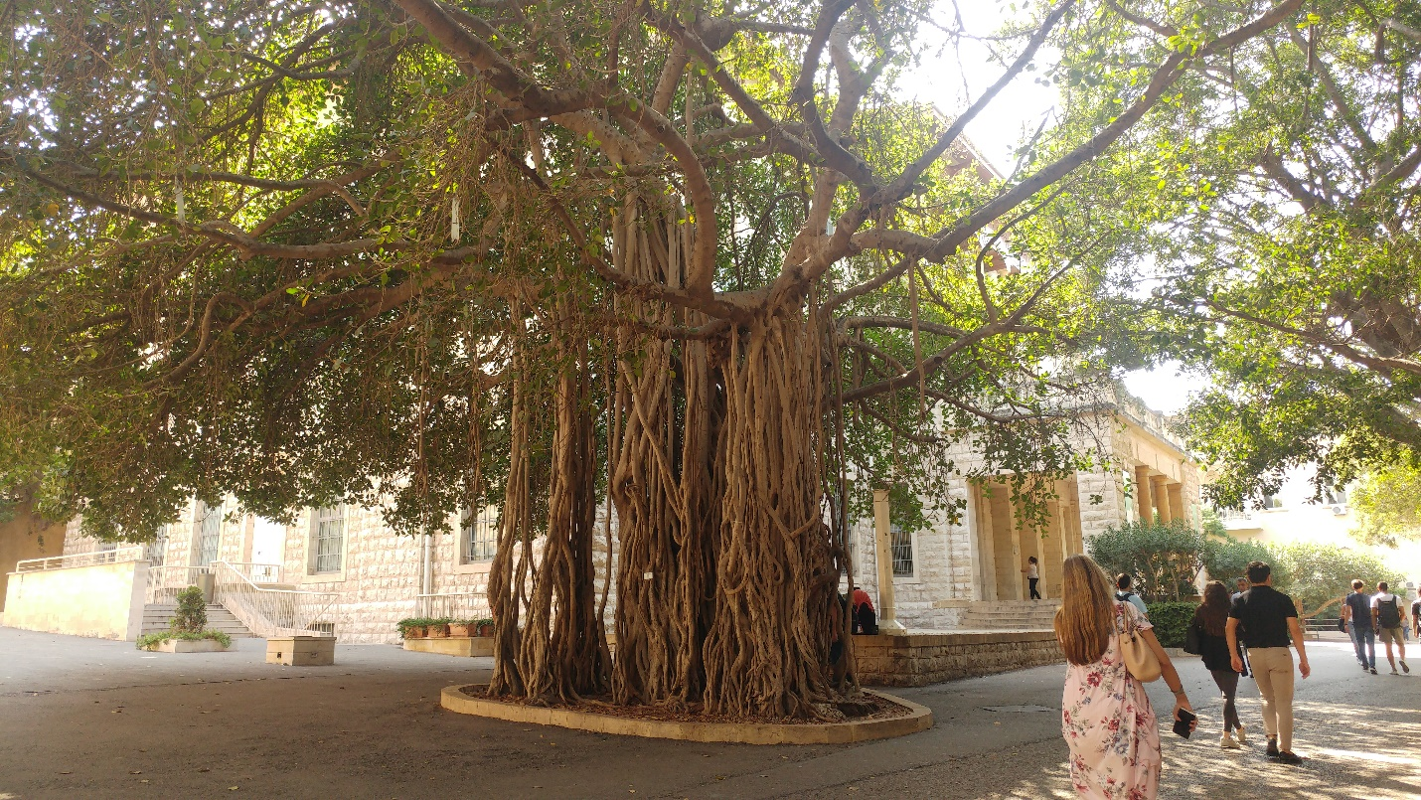

Docent Training Schedule (2018)

2018 SCHEDULE MARCH-APRIL
Monday March 19  FAFS room 205 | Friday March 23  FAFS room 205 | Thursday March 29  FAFS room 205 | Thursday April 05  FAFS room 205 | Friday April 13  FAFS room 205 | Thursday April 19  FAFS room 205
5:00 PM –  6:50 PM | 5:00 PM –  6:50 PM | 5:00 PM –  6:50 PM | 5:00 PM –  6:50 PM | 5:00 PM –  6:50 PM | 5:00 PM –  6:50 PM
Natural History of AUB | Plants of AUB | History of AUB | Environment & Sustainability at AUB | AUB Campus & Wellbeing | Safety
Salma Talhouk  Department of Landscape Design & Ecosystem Management | Monika Fabian  Department of Landscape Design & Ecosystem Management | Jana Al-Mawed Visitors’ Bureau | Aram Yeretzian  Department of Architecture and Design | Beata Dreksler  Department of Landscape Design & Ecosystem Management | Farouk Merhebi  Environmental Health, Safety & Risk Management
2018 SCHEDULE APRIL-MAY
Friday April 27  FAFS room 205 | Friday May 04  FAFS room 211 | Wednesday May 09  FAFS room 205 | Friday May 25  FAFS room 205 | Wednesday May 30  FAFS room 205
5:00 PM –  6:50 PM | 5:00 PM –  6:50 PM | 5:00 PM –  6:50 PM | 5:00 PM –  6:50 PM | 5:00 PM –  6:50 PM
Fundraising | Important Medicinal Plants on AUB Campus | Campus Management | AUB Landscape Character & Identity | Guided Tours & Communication
Nada Charara Mariam Sabbah  Office of Development | Nada Sinnu  Department of Biology | Anis Abdallah  Grounds Keeping | Gabriella Trovato  Nayla Al-Akl  Department of Landscape Design & Ecosystem Management | Tamer Amin  Department of Education

Locations booked: FAFS 205 and FAFS 211 (This document could be annually updated with new changes)

Letter to Prospective Docents

Dear Prospective Docent Volunteer,

Thank you for your interest in becoming an AUB botanical volunteer. Docent volunteers serve in a variety of areas at AUB and are an important part of our events, day-to-day activities, and programs.

This is the current AUB Docent Manual, containing information about our docent service areas, expectations of docent volunteers, and an application form.

Before emailing in your application, read over the Manual carefully so that you are familiar with volunteer expectations and the benefits volunteers receive upon fulfilling these expectations.

Please fill out the enclosed application below and return it to me at aubotanic@aub.edu.lb. Feel free to attach any other document/pdf if it describes your background in more detail.

Thank you again for your interest.
Sincerely,
Ranim
Aub Botanical Garden Coordinator

aubotanic@aub.edu.lb
AUB Botanical Garden
American University of Beirut
Bliss Street, 11-0236
Riad El-Solh 1107-2020, Lebanon
Tel: +961-1-374374 ext 4909

Docent Application Form
Fill out a docent application form to indicate that you are interested in the docent training program.

AUB Botanical Docent Application Form
Name _____________________________________________________ Date ______________ Address ______________________________________________________________________
The best way to contact me (circle one):
Email Cell
Work Home
City _______________________________________________ Postcode__________________
Primary Phone ________________________ Cell Home Work (circle one)
Alternate Phone _______________________ Cell Home Work (circle one)
Email ________________________________________________________
Date of Birth DD/MM/YEAR ___ /___ /_____
Gender? Male □ Female □

Availability: CHECK the day and CIRCLE AM or PM
Monday □ Tuesday □ Wednesday □ Thursday □ Friday □ Saturday □ Sunday □
AM PM AM PM AM PM AM PM AM PM AM PM AM PM
How did you hear about this opportunity? AUBotanic Website ____ Brochure ____
Friends ____ Other ____

Why did you choose AUB Ancillary Botanical Garden for your volunteer experience?
____________________________________________________________________________
Educational Background: (Please list highest level & degrees, if any)

____________________________________________________________________________
____________________________________________________________________________
Work & Volunteer Experience:

____________________________________________________________________________

____________________________________________________________________________

I am interested in helping with the following activities: (mark all that apply)

___ Docent Training Program ___ Special events
___ Tour guide ___ Office help
___ Planning events ___ Fundraising
___ Group outings/trips ___ Exhibits
___ Youth programs/education ___ Garden Maintenance
___ Other:

Skills you wish to highlight:
Languages: Communication & Marketing:
□ Arabic                □ Community Outreach Events
□ English             □ Public Speaking
□ French   □ Cashier
□ Other _______     □ Media releases & Journalism
□ Sign Language        □ Guide & Community Involvement
     □ Event planning
Ecological Knowledge: Arts:
□ Gardening   □ Graphic Design
□ Landscape Design         □ Digital Photography
□ Pruning □ Drawing
□ Composting   □ Illustration
□ Sustainable Design   □ Video-making
□ Environmental Engineer     □ Photoshop
Building Skills:
□ Carpentry
□ Painting
□ Metal work
□ Other _______

Any other skills you would like to use in your volunteer activities? Please describe.
____________________________________________________________________________

I understand that as a volunteer at AUB Ancillary Botanical Garden, I will uphold the mission of AUBotanic, maintain my volunteer membership, and I agree to follow all guidelines and policies set forth by AUB. I understand that I will be required to fulfill training requirements of the program. I am aware that AUB has the right to release me from service at any time.
SIGNATURE ______________________________________ DATE ____________

